 

Project Name:

**VIRTUAL REALITY SYSTEM FOR TOURISM**

Graduation Project final documentation

**Supervised by: Dr.Reda Abdelwhab**

Prepared By:

Taha Gehad Ali

**Table of contents:**

Abstract ……………………………………………………..6

1. Introduction …..……………………………………………7

1.1 Importance of tourism ………………………….. 8

1.2 Virtual Reality ………………………………….. 9

1.3 VR & AR & MR …………………………………11

1.4 VR applications ………………………………….13

1.5 VR history ……………………………………….14

2. Project phases………………………………………………15

2.1 Collect data ………………………………………16

2.2 Design ……………………………………………19

2.2.1Design the scene …………………………….21

2.3 Coding …………………………………………….22

2.4 Headset and platform ……………………………..25

3. Background …………………………………………….... 26

3.1 3D Game Engines ………………………………...27

3.2 3D Modeling software …………….…………….. 29

3.3 Headset Categories …………………….………….31

4. Future work ………………………………………………..33

5. Conclusion …………………………………………………35

6. References ………………………………………………....37

**Abstract**

This document represent our work in a virtual reality project for Egyptian tourism.

The of virtual reality is the new revolution in technology. all the world now looking for try this experience and we want to benefit from this to show the people our great civilization and encourage them to visit Egypt to make the tourism flourish again.

Thanks to the acceleration in hardware industry like making super CPUs and GPUs and making the headsets in the last few years now we can make a great VR experience with low cost. And with the increase of internet usage and mobile applications and the flourish of social media we can spread our applications all over the world.

So why we don’t make use of all of this to raise our economy and civilization?

We start by designing a simple scene for the most famous place in Egypt "the Giza pyramids" and integrate it with movement control that works with google cardboard headset and we add a background music and in front of every structure we make a human model to guide the user and tell him some information about the place.

Chapter 1Introduction

**1.1 Importance of Tourism**

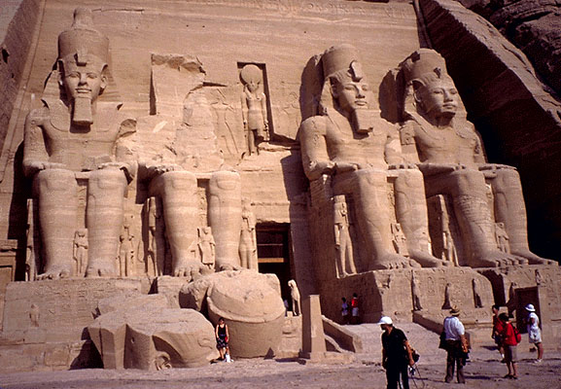 Ancient Egypt is arguably the world's most favorite

And famous ancient civilization, people from all over the world interested in studying the history of ancient Egypt

And tourists from all over countries come to visit Egypt to see the Egyptian arts and ancient monuments.

The main importance of this civilization is that it introduced civilization to the world, they also introduced social classes, agrarian societies and monuments.

The civilization of Ancient Egypt left many monuments and temples that have become attractions for modern-day visitors to Egypt.

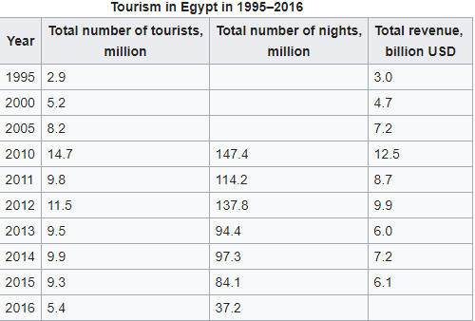

Tourism is one of the leading sources of income, crucial to Egypt's economy. At its peak in 2010 the sector employed about 12% of Egypt's workforce serving approximately 14.7 million visitors Egypt, and providing revenues of nearly $12.5 billion. As well as contributing more than 11% of GDP and 14.4% of foreign currency revenues.

For the importance of tourism and the importance of the ancient Egypt civilization, computer scientists and software engineers should take care of this part in their projects and give this field some effort to help our country and raise our history or even the history of mankind.

**1.2 Virtual Reality**

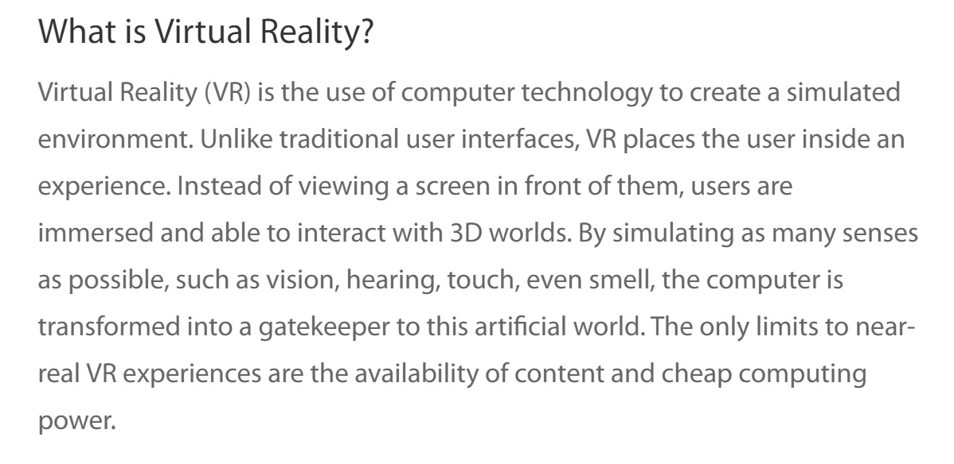

Virtual reality (VR) means experiencing things through our computers that don't really exist. From that simple definition, the idea doesn't sound especially new. When you look at an amazing Canaletto painting, for example, you're experiencing the sites and sounds of Italy as it was about 250 years ago—so that's a kind of virtual reality. In the same way, if you listen to ambient instrumental or classical music with your eyes closed, and start dreaming about things, isn't that an example of virtual reality—an experience of a world that doesn't really exist? What about losing yourself in a book or a movie? Surely that's a kind of virtual reality?

If we're going to understand why books, movies, paintings, and pieces of music aren't the same thing as virtual reality, we need to define VR fairly clearly.

A believable, interactive 3D computer-created world that you can explore so you feel you really are there, both mentally and physically.

Putting it another way, virtual reality is essentially:

1. **Believable**: You really need to feel like you're in your virtual world (on Mars, or wherever) and to keep believing that, or the *illusion* of virtual reality will disappear.
2. **Interactive**: As you move around, the VR world needs to move with you. You can watch a 3D movie and be transported up to the Moon or down to the seabed—but it's not interactive in any sense.
3. **Computer-generated**: Why is that important? Because only powerful machines, with realistic 3D computer graphics, are fast enough to make believable, interactive, alternative worlds that change in real-time as we move around them.
4. **Explorable**: A VR world needs to be big and detailed enough for you to explore. However realistic a painting is, it shows only one scene, from one perspective. A book can describe a vast and complex "virtual world," but you can only really explore it in a linear way, exactly as the author describes it.
5. **Immersive**: To be both believable and interactive, VR needs to engage both your body and your mind. Paintings by war artists can give us glimpses of conflict, but they can never fully convey the sight, sound, smell, taste, and feel of battle. You can play a flight simulator game on your home PC and be lost in a very realistic, interactive experience for hours (the landscape will constantly change as your plane flies through it), but it's not like using a real flight simulator (where you sit in a hydraulically operated mockup of a real cockpit and feel actual forces as it tips and tilts), and even less like flying a plane.

**1.3 What is VR, AR, MR and XR!**

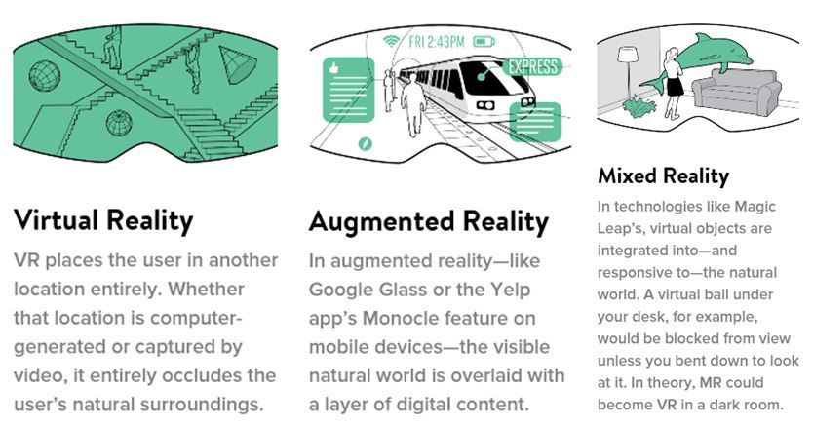

**Virtual reality** (VR), augmented reality (AR) and mixed reality (MR)are emerging technologies utilizing a variety of digital (artificial) immersion and overlays on the real world that users can interact with.

Virtual Reality (VR) encompasses immersive experiences and content via a VR headset or HMD (head-mounted display). The content is 100% digital and computer generated. Current reality is replaced with a new 3D digital environment in which the user is isolated from the real world.

**Augmented reality** (AR) overlays computer-generated content on top of the real world. This superimposed digital overlay can superficially interact with the environment in real time. AR is primarily experienced via a wearable glass device or through smartphone applications.

**Mixed reality** (MR) combines several technologies into one wearable device. MR lenses or headsets present an overlay of digital content that interacts with objects in the real world in real time. The products are, in most cases, in research and development phase, but MR is viewed through transparent wearable glasses.

**To understand the Difference between VR, AR, MR TECHNOLOGIES**

Virtual, augmented, and mixed reality have some fundamental differences. The number of products, and the pace of the technology, is moving along at a very fast rate. As is the increased use and application of the technology in a variety of industries and applications.

* Virtual Reality: VR is content which is 100% digital and can be enjoyed in a fully immersive environment.
* Augmented Reality: AR overlays digital content on top of the real-world.
* Mixed Reality: MR is a digital overlay that allows interactive virtual elements to integrate and interact with the real-world environment.

In 1984, Professor Paul Milgram and Fumio Kishino presented the Milgram Mixed Reality Spectrum to explain the range of virtual and augmented reality. This scale was the base most manufacturers had used for 30 years.

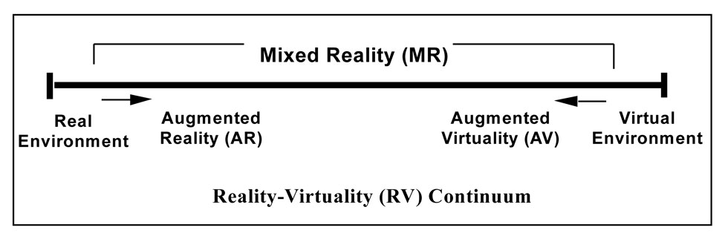

*Milgram Mixed Reality Spectrum presented in 1984.*

**1.4 VR Applications**

It started off as a research project to make better flight simulators, however, since it’s rebirth VR has been used in many different areas across a variety of industries. Here are some of the more notable examples:

* **Healthcare**: Surgical Theater allows surgeons to analyze a patient’s anatomy, locate tumors and plan an operation more efficiently.
* **Space**: NASA uses VR for spacewalk training and to control robotic arms.
* **Museums**: While many cultural institutions have the ability to view parts of their collection in VR, the Kremer Museum exists entirely within virtual reality and was designed by a world famous architects.
* **Automotive**: Ford Vehicle Immersion Environment (Five) allows Ford employees to have a detailed look at an upcoming model and plan any changes to it.
* **Military**: US army uses VR for various training scenarios and for treating PTSD for soldiers returning from battle.
* **Real estate**: Many real estate companies are using VR to showcase some of their properties, Planner 5D has created a drag and drop tool to create your future home interior and walk around it with the help of mobile VR.
* **Architecture**: Employees at Gensler LA offices meet every week in a virtual replica of a building that is currently being designed by their architects.
* **Social networking**: There are many apps like VR Chat and Sinespace that allow people to interact and create in a virtual world.
* **Education**: Class VR creates opportunities for immersive teaching in the classroom.
* **Sports**: STRIVR creates training regimens for sports teams, which allow players to do some extra training on their own time to repeat team strategies.

**1.5 History of VR**

History of VR starts with the very first demo of a Sword of Damocles in the MIT lab in 1968. Back then VR was mostly a test for military flight simulators and screen technologies. There were many failed attempts to make VR a reality in the mid 20th century, but most of them resembled very basic demos that would take up too much space, and could only be afforded by the largest R&D labs.

The first real wave of VR hype came and passed in the early 90s. There were companies making very expensive and cumbersome VR headsets, such as Virtuality 1000CS. There was even a TV show called VR Rangers showing kids the wonderful journeys of VR warriors looking suspiciously similar to Power Rangers.

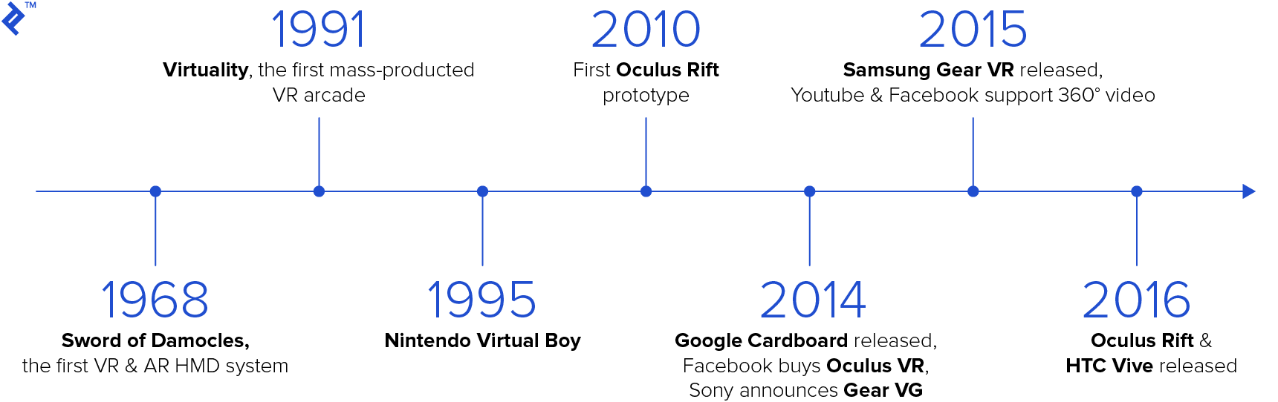

However, the technological capability in the graphics space of the early 90s was not a match for the requirements of the VR systems. Most people have reported side effects of using VR displays at the time. Nausea and sea sickness was accompanying almost all the experiences. Most games couldn’t produce much more than a few simple shapes, and VR was forgotten for another 15 years.

Then came the rise of the Oculus Rift, starting with their Kickstarter campaign in early 2010, which has brought VR out of the shadows and into the mainstream consciousness again.

Chapter 2Project Phases

**2.1. Collect data**

We start by collecting data and get information about the most important places that tourist want to visit when they come Egypt and it clearly that the Giza pyramids is the most wonderful and magic place in Egypt and even all over the world. The Great Pyramid ofGiza is the oldest monument on the list of the Seven Wonders of the Ancient World.

All tourists says that "No trip to Egypt is complete without visiting the Pyramids of Giza".

Then we tried to get the information about it and appears that it has five main structure

The great pyramid (Khufu).

The mid pyramid (Khafraa).

The small pyramid (Mankuraa).

The great sphinx.

The queen pyramids.

So we collect data about each one first for the design and second to produce this information to the tourist or the VR experience.

Most of this information about the dimensions of the structures brief introduction of the places.

We collect many pictures to make full imagination of the place and get complete map.

**Example of the pictures:**

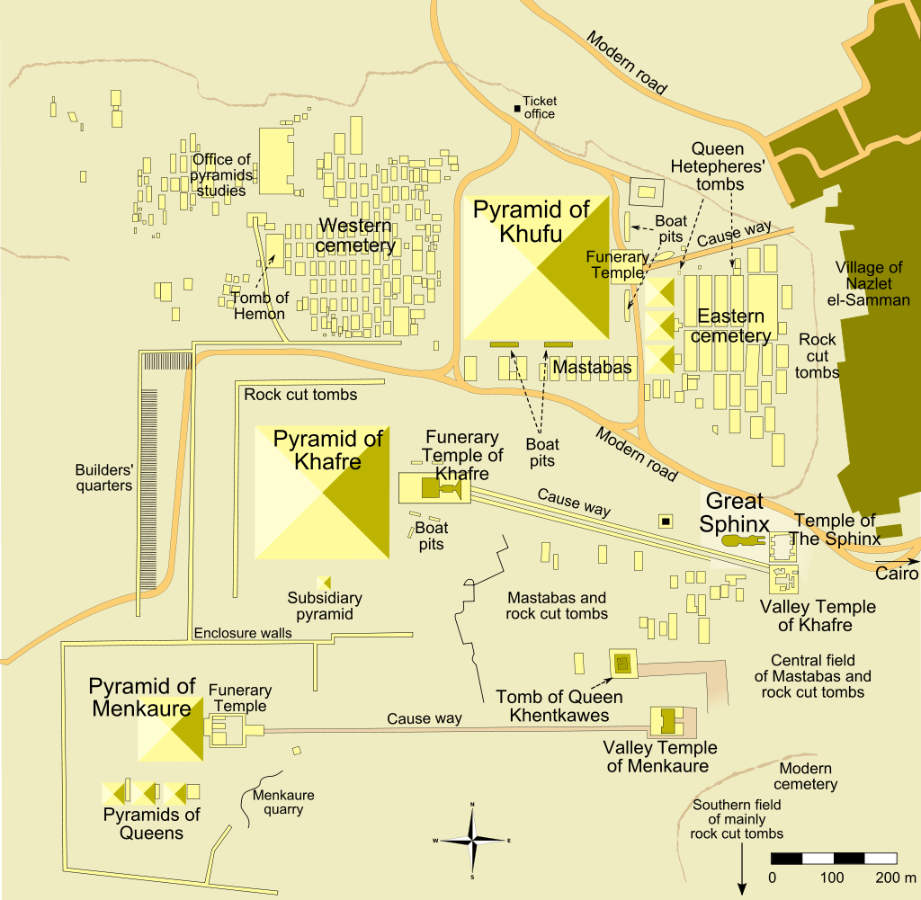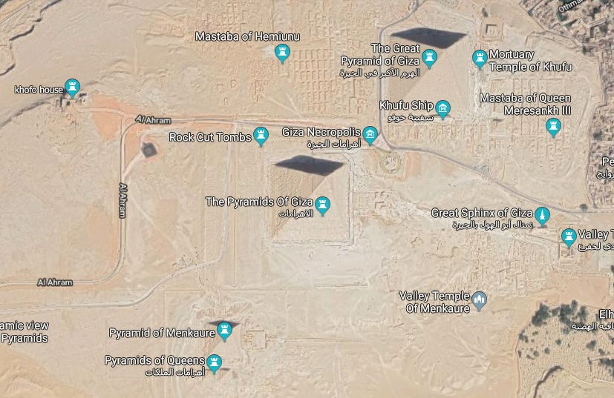

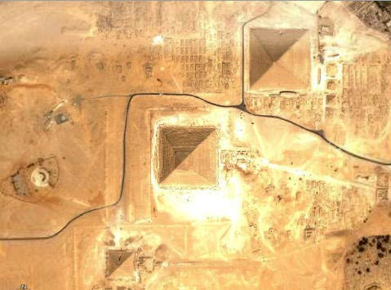

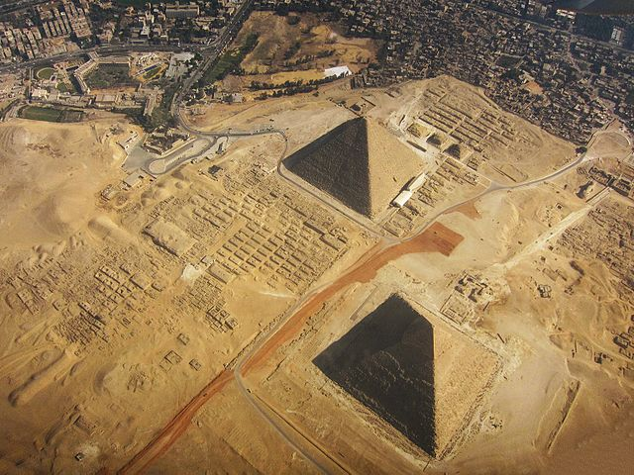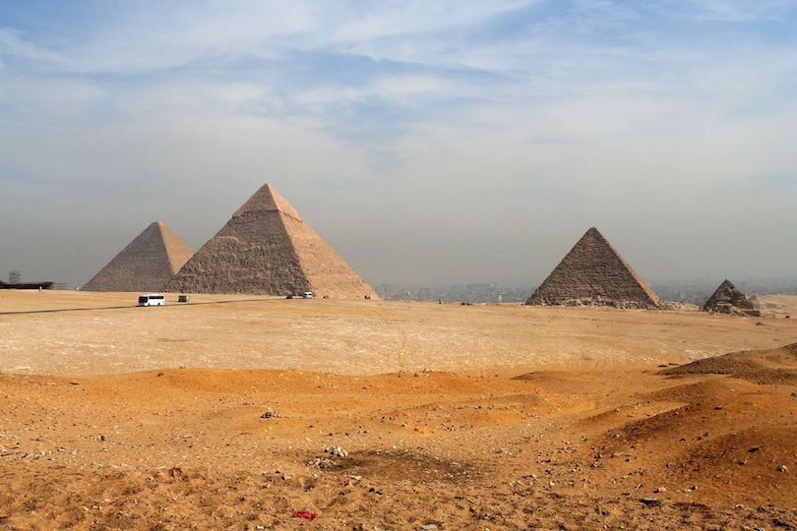

2.2 Design

After collecting the information we get the full picture and now we start the design of the main structures. And we have

1-pyramids.

2-small pyramids.

3-sphinx.

4-roads.

5-rocks and stones.

6-the sand martial.

To accomplish this mission we start searching for 3d modeling software and there are many software and the most famous software is Maya, 3d Max and Blender.

We use Blender because it is for beginners and free to use and it suitable with our simple work.

We made a low poly designs that suitable with our needs because we will use it in mobile VR that have low graphic and memory capacity.

**2.2.1 Examples of designs:**

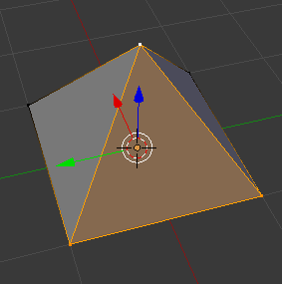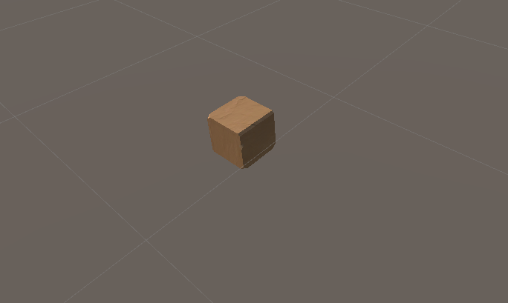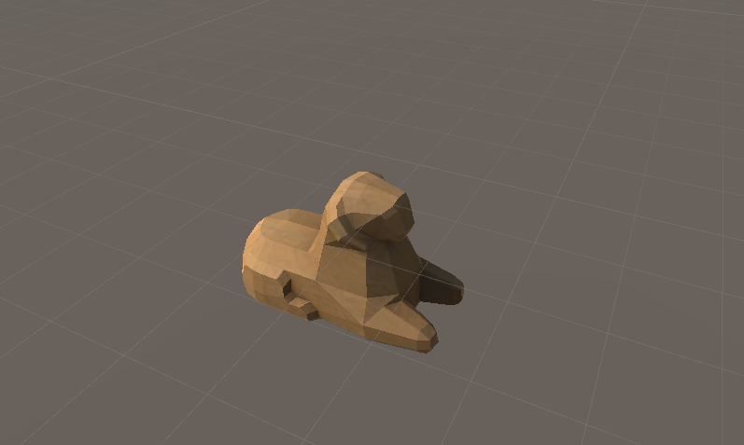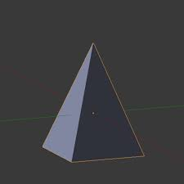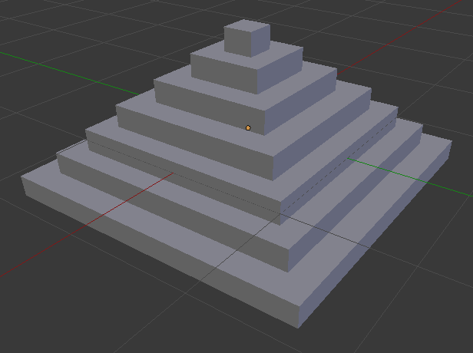

**2.2.2 Design the scene:**

Gettingthe whole picture in the unity design space take in considerations the dimensions of every structure.

Here is some examples of the complete scene

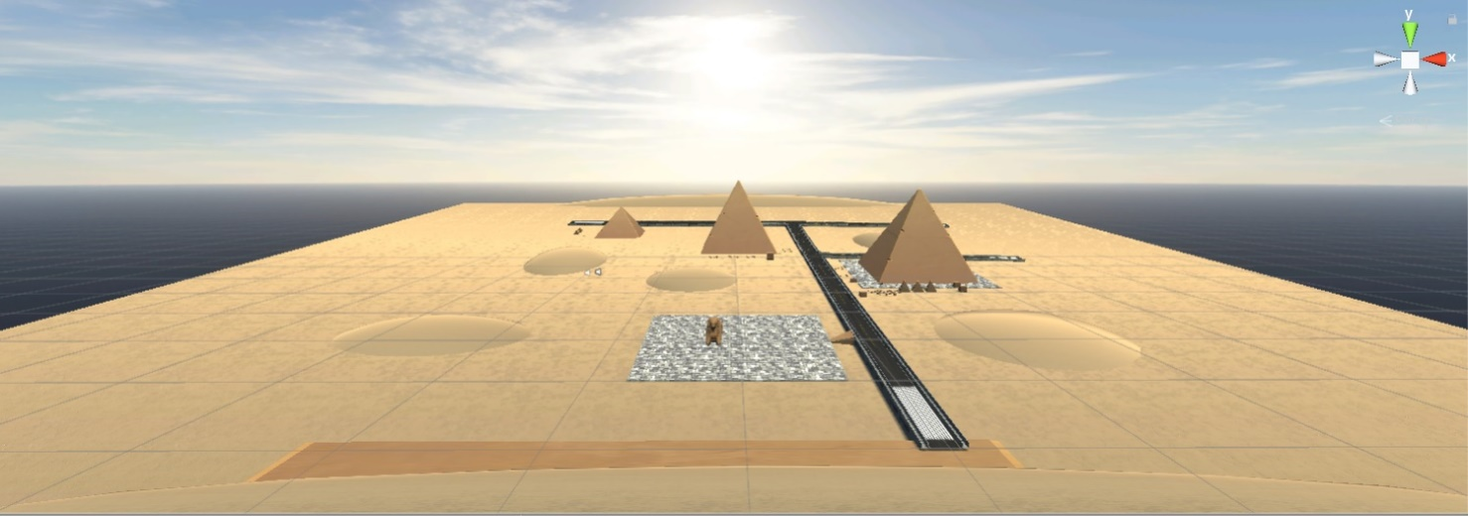

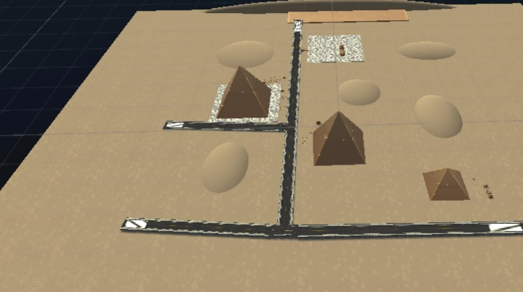

2.3 Coding

Now we need to make the VR experience more interactive so we start to code the movement and voice interaction unfortunately the VR headsets had too little control units not like the Personal Computers and mobile phones.

In headset like Google cardboard there is only one button to use so we need to adapt our VR experience to work with only one controller.

To achieve this we use Unity3D game engine and C# as programming language.

Starting by make simple movement controller that we construct an array of targets that the user will move to it every time he will click the button then every time he click we calculate the distance between the two points (the current one and the next target).

We use the "Vector3.MoveTowards" function to move this step with the our constant speed that we define it as float point when he reach the next point he stops waiting for the next instruction.

Moving to the speech part we use simple strategy according to the limitation of control that we use the camera ray to produce a trigger if it hit a collider and we make this collider the guide giving the object a name and define an array of audio clips for it and for every object we run the specific audio clip that contain the information about it.

And for background music we look for a suitable music for ancient Egyptian pharaohs.

We used IBM Watson SDK to convert text to speech.

**Examples of our code:**

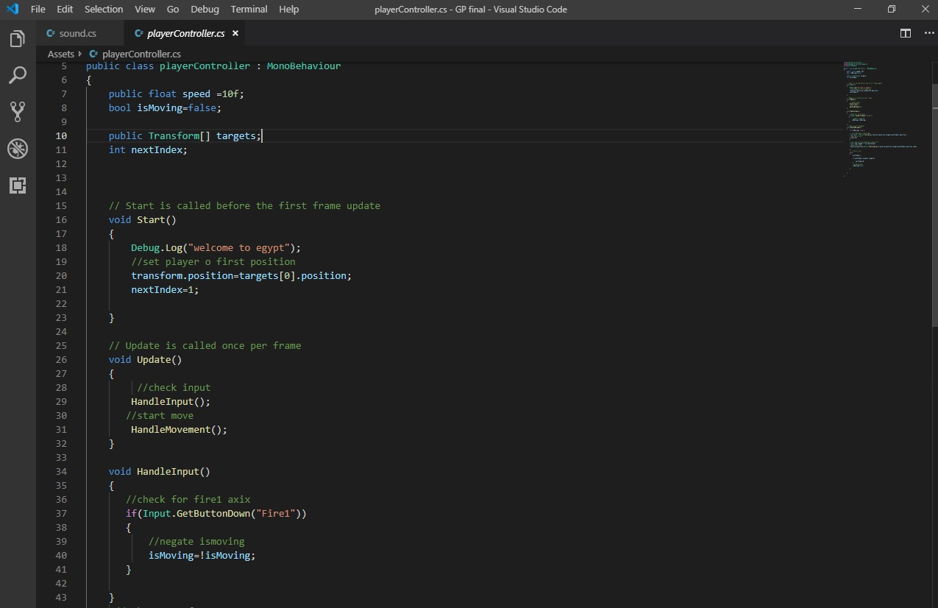

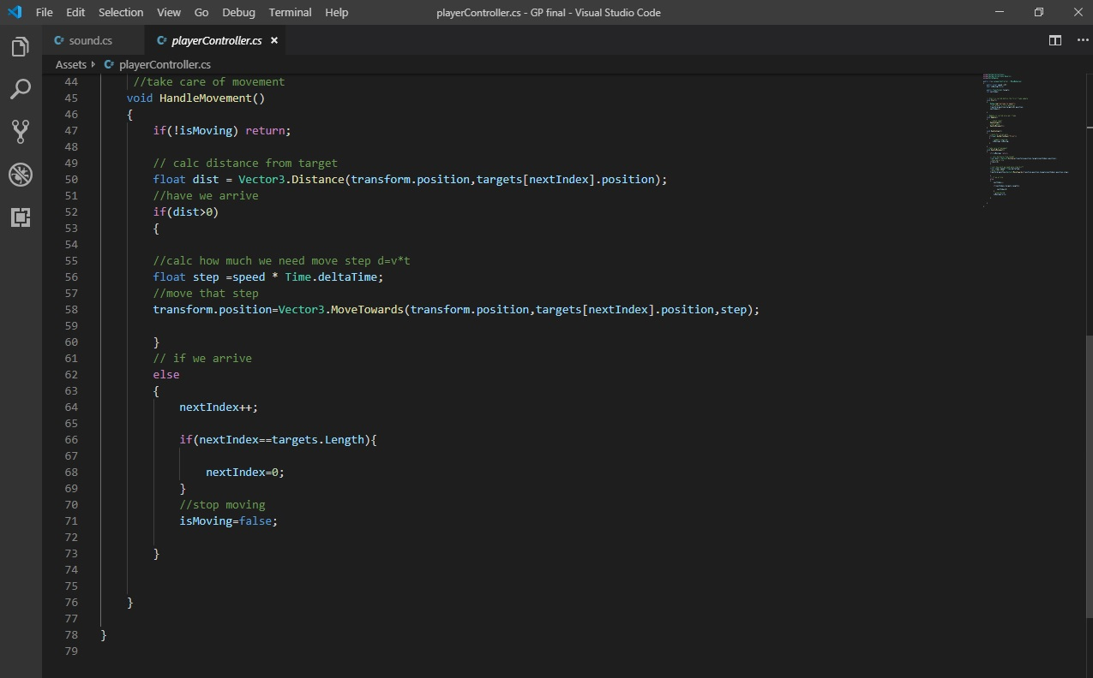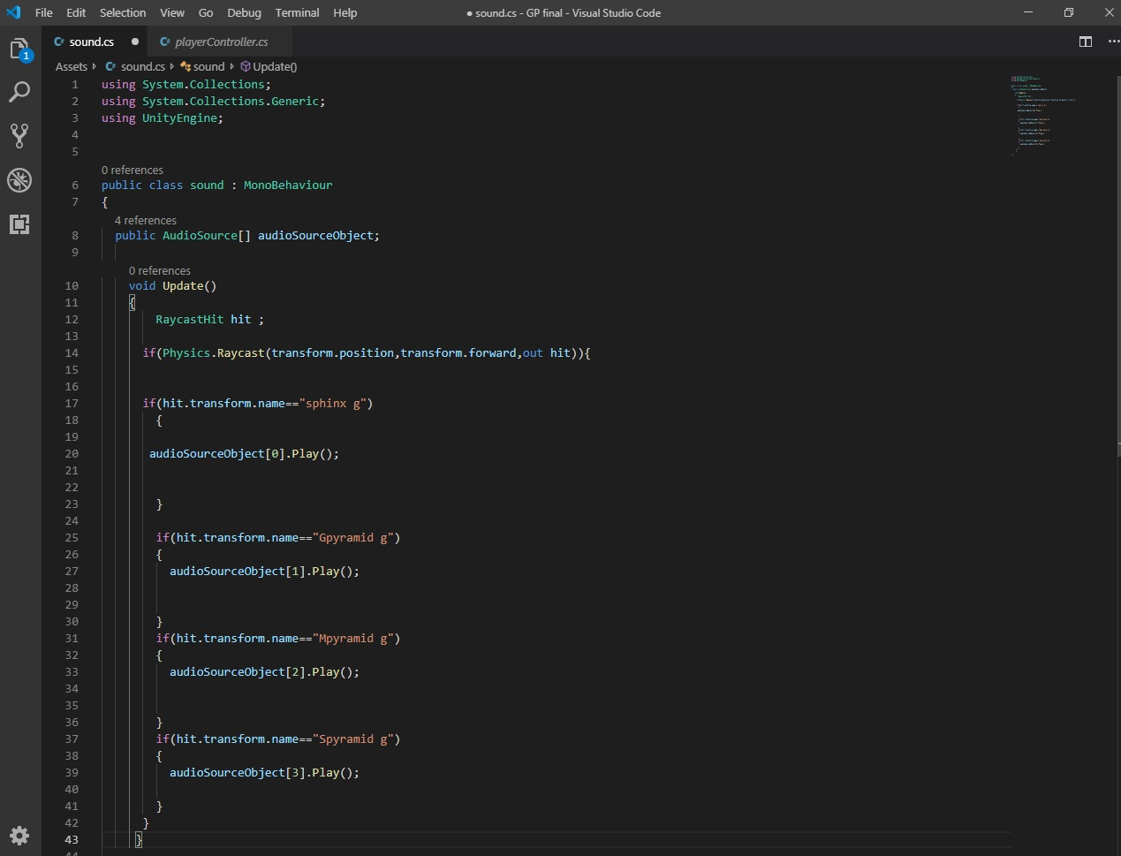

2.4 choose headset and platform

 There are many different VR platforms available. There are at least 30+ different VR devices available across both desktop and mobile VR markets.

This means that supporting your VR app on all of the platforms would require a lot of additional tweaking and rework. It’s especially difficult to share content between mobile VR and desktop VR apps since they support very different levels of 3D graphics and animations.

Using a 3D game engine such as Unity 3D or Unreal Engine helps because they allow an app to be theoretically deployed to more than one platform with minimal rework. In practice, it is easy to share the builds between most high-end desktop VR systems, however, mobile VR might need additional rework and new 3D assets to work smoothly.

So we choose google cardboard headset because its most common mobile based headset now as it's cheaper and easier to use and buy.

We add the Google VR SDK to our project and import the main viewer to the scene and now it's ready to simulate the VR movement.

Last thing for the build setting we activate the XR setting and Google cardboard as VR device.

Chapter 3background

3.1 3D game engines

Most VR projects use either Unity 3D or Unreal Engine for making this task much easier. 3D game engines have certain graphics and control features, which help to cut the development time and cost up to 20x when compared to making your own 3D engine. 90% of VR content produced today is using Unity 3D.

**Unreal Engine**

Unreal Engine is another one of the most popular game engines available today and is known specifically for first-person shooters, but is great for MMORPGs, RPGs, fighting, and stealth games. Cross-platform, Unreal is compatible with a massive spectrum of operating systems and devices and there’s a good chance you’ve played an Unreal-powered game.

Pros

* Includes a profiler in the default version
* Unreal Engine’s graphical capabilities are far ahead of the competition
* Asset store with some good templates

Cons

* Uses C++ which requires more programming experience than C# or Javascript
* Epic Games (makers of Unreal) get 5% royalty on everything you earn
* Limited third-party APIs compared to other engines
* Builds aren’t optimized well for lower spec devices.

**Unity**

Unity gives you just about everything you need to build games in one package. It’s an integrated development framework that delivers rich solutions and out-of-the-box functionality to create games. It allows you to assemble assets and art into environments and scenes, add audio, special effects, lighting, and animations.

Unity is also the most popular game engine in the world, with a 45% market share, and touches over 600 million gamers across the globe.

**Pros**

* Unity supports 25 platforms and some of the best ones to monetize on: iOS, Android, Nintendo Switch, Steam, VR/AR etc.
* Powerful graphical engine that’s optimized for many devices (consistent FPS across hundreds of devices)
* Supports coding in JavaScript and C#
* Drag and drop interface
* Huge community of developers
* Pricing is fair
* Huge asset store with prebuilt templates that are plug and play
* 2D and 3D support Cons
* Learning the engine is very complicated
* New developers might feel overwhelmed due to the complexity of the engine
* Optimizing graphically intensive games can be difficult (needs custom models, etc.)
* Integrating mobile APIs, advertising, etc. is more challenging than other engines.

**3.2 3D Modeling Software**

Below are the top most comparisons between Maya & 3d Max and Blender

|  |  |  |  |
| --- | --- | --- | --- |
|  | **Maya** | **Max** | **Blender** |
| **Definition** | Maya is an Autodesk software, mainly designed for animation and texturing. | Max is an Autodesk software mainly designed for modeling, architecture designs, engineering, and construction. | A blender is a software designed by the Blender Foundation, mainly for animation and visual effects. |
| **User Experience** | Difficult to learn but once you know about Maya in and out, there is nothing better for 3D modeling and animation. | Learning Max is not all that difficult because, unlike in Maya, it starts showing automated results after few steps. | The designers who are not much comfortable and experienced on working with Maya would probably opt for Blender. |
| **Features** | It has more of 3D animation and texturing features. | It has more modeling features, suitable for 3D architectural designs, models, engineering models | Blender has more animation and visual effect features, mainly for films and entertainment sectors. |
| **Availability** | Maya is licensed software. | Max is also a licensed software. | Blender is available for free. |
| **Usage** | Large production studios mostly prefer Maya. | Max is mostly handy for games development and architecture designs. | Mostly fit for small start-ups, into 3D animation and visual effects. |

3.3 Headset Categories

A number of key manufacturers, startups, and crowd funded products have emerged to produce a range of VR products. These include technology giants such as Facebook (through their acquisition of Oculus), Google (with a series of Daydream headsets), HTC (VIVE), Samsung (Gear VR), and Windows (who have named their range of devices Windows Mixed Reality, even though a number are VR-only enabled.) Startups have emerged and managed to gain huge investments too.

There are three types of VR devices available and each have their own criteria and pros and cons.

**Tethered VR**

Tethered virtual reality headsets currently are much more immersive than other types of VR. These tethered VR headsets require a cable connection to a powerful gaming PC for a superior desktop VR experience. Most of the Windows Mixed Reality headsets fall in this VR category and are considered virtual reality within the industry, and not mixed reality. (ASUS HC102, Acer Mixed Reality headset, Dell Visor, HP Mixed Reality headset, Samsung HMD Odyssey).

Examples of popular PC VR headsets: Oculus Rift, HTC VIVE Pro.

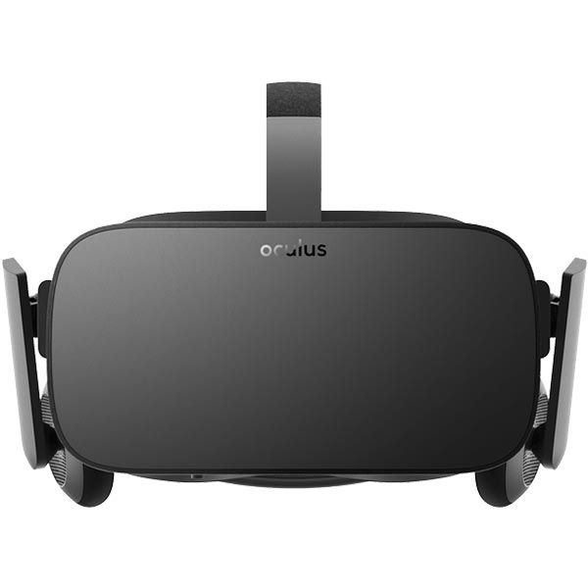

**Standalone VR**

These standalone headsets (wireless VR) don’t require a connection to a PC or a smartphone and are generally a more affordable option.

Examples of the most popular standalone VR headsets: Pico Neo, VIVE Focus, Oculus Go.

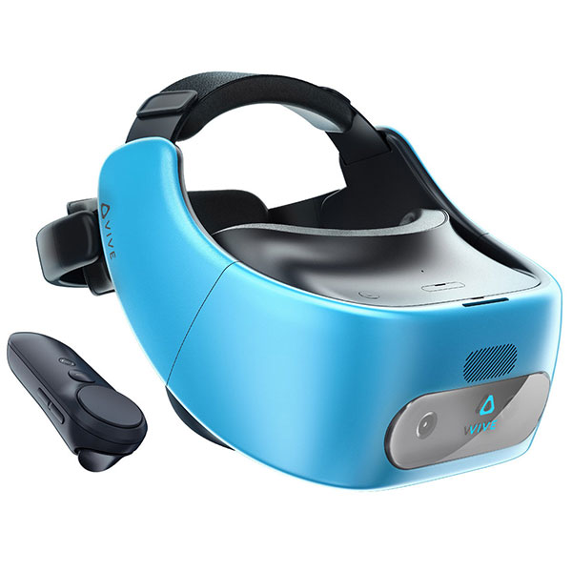

**Smartphone VR**

Mobile virtual reality through smartphone headsets has allowed many users to have their first VR experience. The range of devices available, the affordable price range, combined with the number of users who own smartphones, means this VR category is the most diverse in terms of products. The type of screen and its resolution is a key factor in smartphone VR headsets as well as battery life.

Examples of the most popular smartphone VR headsets: Samsung Gear VR, Google Daydream, Google Cardboard.

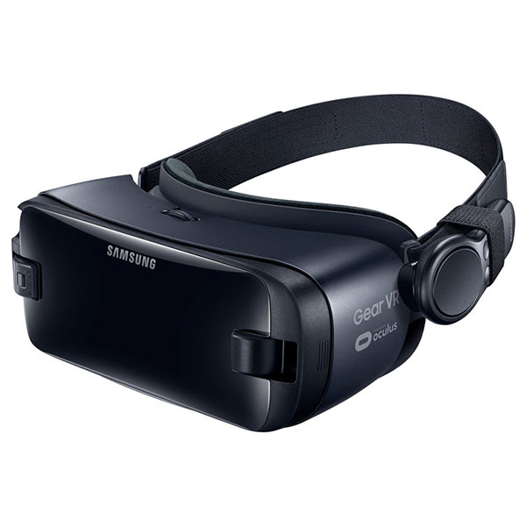

**Future Work**

First we need to make more realistic designs to improve the experience

but this need advanced design skills.

Then we want to add speech recognition system to make it more interactive

with the users.

And it need some kind of user interface with more options.

At the end want to make our virtual reality application to run in cross platforms

and work with another headsets to let more users to have the experience.

**Conclusion**

We developed a virtual reality experience for Egyptian tourism.

At first we collect information about places then

we choose to make it about the Giza pyramids

Second we start designing the main structure of this place after this

we construct the full scene.

Third we start the coding the user more interactive

with the environment take in consideration the limitation of controllers.

Fourth we get animation for the guide to make it more realistic.

In the end we choose google cardboard headset and android mobile platform

to launch the application.

**References**

1. *Virtual Reality Technology by Grigore Burdea and Philippe Coiffet. Wiley-IEEE, 2017. Popular VR textbook covering history, programming, and applications.*
2. *Learning Virtual Reality: Developing Immersive Experiences and Applications for Desktop, Web, and Mobile by Tony Parisi. O'Reilly, 2015. An up-to-date introduction for VR developers that covers everything from the basics of VR to cutting-edge products like the Oculus Rift and Google Cardboard.*
3. *Developing Virtual Reality Applications by Alan B. Craig, William R. Sherman, and Jeffrey D. Will. Morgan Kaufmann, 2009. More detail of the applications of VR in science, education, medicine, the military, and elsewhere.*
4. *Virtual Reality by Howard Rheingold. Secker & Warburg, 1991. The classic (though now somewhat dated) introduction to VR.*
5. *Want to Know What Virtual Reality Might Become? Look to the Past by Steven Johnson. The New York Times, November 3, 2016. What can the history of 19th-century stereoscopic toys tell us about the likely future of VR?*
6. *A Virtual Reality Revolution, Coming to a Headset Near You by Lorne Manly. The New York Times, November 19, 2015. Musicians, filmmakers, and games programmers try to second-guess the future of VR.*
7. *Virtual Reality Pioneer Looks beyond Entertainment by Jeremy Hsu. IEEE Spectrum, April 30, 2015. Where does Stanford VR guru Jeremy Balinese see VR going in the future?*